|  |  |
| --- | --- |
| **NAME** | **Mohamed Abdullah.M** |
| **TEAM ID** | PNT2022TMID37442 |
| **PROJECT** | **IoT Based Safety Gadget for Child Safety Monitoring & Notification** |

**CREATE IOT PLATFORM & DEVICES**

**ANALYTICS**

Completely manage your IoT landscape and make better business decisions. Using a secure, smart and scalable platform as the hub of your IoT, get real-time analysis of user, machine and system-generated data, including speech, text video and social sentiment. You need contextual insight for truly cognitive IoT applications.

**WATSON IOT PLATFORM**

Think of an Internet of Things platform as a group of technologies that provide the building blocks for developing your product. IoT platforms provide the “infrastructure” you use to create the specific features of your solution.

The goal of an IoT platform is to provide all the generic functionality for your application so you can focus on building features that differentiate your product and add value for your customers.

By taking over the non-differentiated functionality, IoT platforms help you reduce your development risk and cost, and accelerate your product’s time to market.

When people talk about IoT platforms, they often launch into technical jargon like transport protocols, rules engines, data lakes, etc. While those considerations are important and deserve thoughtful planning, they don’t clearly illustrate how an IoT platform can help you.

Let’s break down the key tasks that an IoT product needs to perform, highlighting the functions your IoT platform should cover. An IoT product needs to:

1. Acquire real-world data via sensors
2. Analyze data locally (edge computing)
3. Connect to the cloud to transmit data and receive commands
4. Store data in the cloud
5. Analyze data in the cloud to [create insights](https://danielelizalde.com/insights-not-data/)
6. Command the “things” to perform specific tasks based on insights
7. Present insights to users

**IOT SECURITY**

Govern applications and devices within an IoT ecosystem by recognizing usage and performance patterns and detecting anomalies, and validating IoT data and transactions.

As a cloud-hosted service the IBM Watson™ IoT Platform service embeds security as an important aspect of its architecture.

The following document answers some common questions about how your organization's data is protected, focusing on specific areas:

* Compliance: external standards, which set benchmarks for security.
* Authentication: assuring the identity of users, devices or applications that are attempting to access your organization's information.
* Authorization: assuring that users, devices, and applications have permission to access your organization's information.
* Encryption: assuring that data is only readable by authorized parties only and cannot be intercepted.

**Platform Service Terminology**

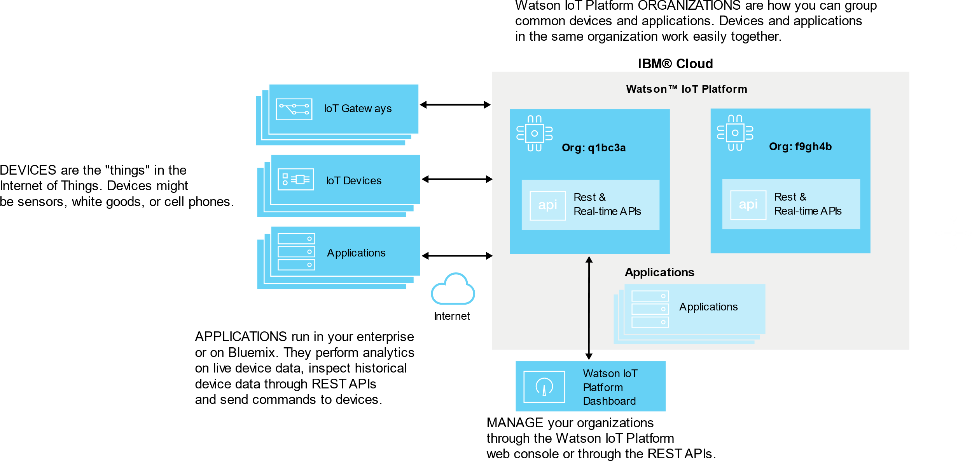

**MANAGE IOT DATA**

Quickly and easily analyze data, perform rich analytics from structured and unstructured sources and gain your own IoT data historian. Parse, filter and transform data; cache or archive data selectively for off-platform analytics or for integration with IoT apps.

**IOT DEVICE PLATFORM**

The reason is that early on, you don’t have validation of what exactly solves your customer’s problems. Therefore, it’s better to spend your time and money running quick experiments, as opposed to building expensive hardware that you don’t know your customer wants.

As you gain traction in the market, your focus will shift from product-market fit, into the pursuit of profitability. That is the time to invest in custom hardware for miniaturization, reduced cost of the bill of materials (BOM), longer battery life, better supply chain agreements, improved serviceability, etc.

So what does an IoT device platform look like? Here are some examples for each stage of the IoT adoption lifecycle.

#### **IoT device platforms – Pre-product-market fit**

Your goal at this stage is innovation. This requires you to understand your customer’s needs and propose potential solutions to address them. Your focus should be to create quick prototypes you can share with your potential customers and iterate as quickly as possible. This is the perfect time to leverage full off-the-shelf hardware components to build your prototypes.

You can use single-board computers with sensors such as [Arduino](https://www.arduino.cc/) or [Raspberry Pi](https://www.raspberrypi.org/). If you need industrial hardware, you can try hardware platforms like PXI or Compact RIO from National Instruments. You can also use a laptop and attach sensors via USB or a PCI card. Or use a smartphone or tablet since they already have a lot of sensors.

#### **IoT device platforms – When a**pproaching product-market fit

As you approach product-market fit, you might need to develop increasingly customized IoT devices that more closely resemble the functionality and form-factor of your final product.

For this stage, you can also leverage hardware components like Arduino, Beagle Bone, Raspberry Pi, or the OEM version of CompactRIO as the core of your device. Your hardware engineering team can use these building blocks as part of your own custom hardware to create a semi-custom IoT device.

At this stage, your focus is not only functionality but also form-factor. The IoT device enclosure, hardware user interface, etc., are elements that require the focus of both your engineering and industrial design teams.

#### **IoT device platforms – At s**cale

Once you find product-market fit and are ready to scale, it’s time to invest in custom hardware. Your goal is to optimize for form-factor, cost, supply chain, and serviceability.

The IoT device platforms you used pre-market fit might be too expensive or bloated to deploy at scale. At this stage, it’s common to completely redesign your IoT device to meet your specific product and company goals.

The IoT device platforms you’ll encounter at this stage, usually come directly from chip manufacturers such as Intel, ARM, Nordic, and Xilinx.

You can also work with either Cloud vendors or connectivity vendors who can help you select and integrate the best hardware for your IoT product. They can also assist you with reference architectures and partners that can help with your IoT device design and manufacturing at scale.

### **Platform to build an Watson IoT application**

IoT platform serves as a middleware that manages the interactions between a user application and remote devices.

Such platforms cover the following 3 major blocks of services:

1. device control and monitoring, security and firmware updates;
2. data acquisition, transformation, processing, and storage;
3. event-driven logic, analytics, and visualization for Internet of Things app development.

So an IoT platform significantly simplifies and speeds up IoT solution development by providing the generic layer your application is based on. However, the decision to buy ready-made IoT platform services or develop the whole IoT system from scratch depends on multiple factors such as the amount of data you are going to stream, process, and store, data processing speed, safety, scalability, etc. The list goes on depending on the specificity of your project. Another influencing factor is the price, as it may appear too high to make economic sense in the case of a large project with a sheer volume of data.